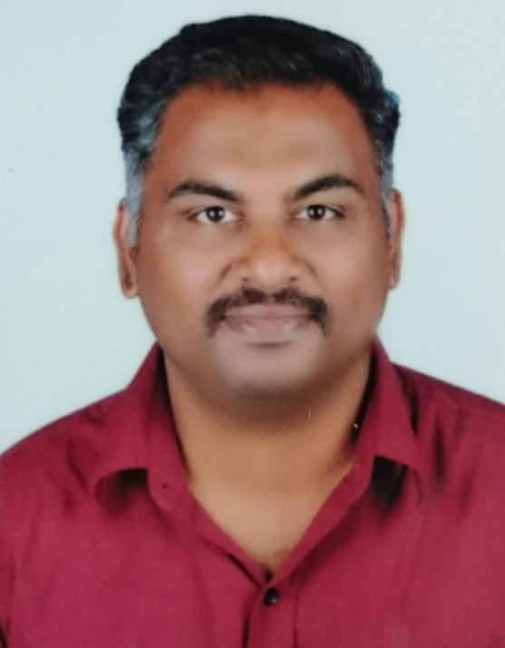
M.H.MOHAMED FAIZAL
Assistant Professor
Department of Electronics & Communication Engineering.
Bharathiyar College of Engineering & Technology
Karaikal, Pondicherry state, India
Mail: fai.ece@gmail.com , mhmohamedfaizal@gmail.com
Cell: +91 9500422702

OBJECTIVE

- To secure a challenging position in the field that will utilize my skills and knowledge to the maximum and provide an opportunity for my career advancement as well.

ACADEMICS

QUALIFICATION | COLLEGE | PERFORMANCE | YEAR
M.E  (Computer and Communication Engineering) | Pavendar Bharathidasan College of Engineering & Technology, Trichy, Tamil Nadu, India | 7.80 CGPA | NOV’2012
B.E.  (Electronics and Communication Engineering) | Bharathiyar College of Engineering and Technology, Karaikal, Pondicherry State, India | 7.62 CGPA | MAY’2008
DIPLOMA  (Electronics and Communication Engineering) | Karaikal Polytechnic College, Karaikal, Pondicherry State, India | 81.42 % | APRIL’2005
SSLC | M.E.S High School, Karaikal, Pondicherry state, India | 85.2 % | MARCH’2002

TECHNICAL SKILLS

- Hardware Skills
Computer Installation & Trouble Shooting, Electronic project design, Communication project design
- Software Skills

MATLAB, LABVIEW, NS2, PSPICE, PROTEUS

Total Experience: 8 years 11 months

ORGANIZATION | POSITION | FROM | TO | DURATION
Bharathiyar college of Engineering & technology, Karaikal | Assistant Professor | 16-7-2012 | Till date | 6 years 11months
Bharathiyar college of Engineering & technology, Karaikal | Lecturer | 14-6-2010 | 2-9-2010 | 3 months
E.G.S Pillay Engineering College, Nagapattinam | Lecturer | 18-8-2009 | 8-6-2010 | 10 months
E-Global Network Solution, Karaikal | Network Associate | 11-6-2008 | 28-5-2009 | 11 months

International Conferences/National Conferences/Workshops/Seminars:

- Session Chair person in the International Conference on “Advanced Concepts in Computational Engineering and Sciences ICACCES’19’” organized by Department of Electronics and Communication Engineering on March 2019 at Bharathiyar College of Engineering & Technology, Karaikal.
- Co-ordinate member in the International Conference on “Advanced Concepts in Computational Engineering and Sciences ICACCES’19’” organized by Department of Electronics and Communication Engineering on March 2019 at Bharathiyar College of Engineering & Technology, Karaikal.
- “Modern D2D Communication for Enhancing RSS in LTE advanced framework” Presented in National Conference on Innovations in Communication and Computing on 28th March 2018 organized by SNS College of Technology at Coimbatore.

- One day workshop attended on “4G LTE Systems” organized by Department of Electronics and Communication Engineering on 8.10.2016 at Rajiv Gandhi College of Engineering & Technology, Pondicherry.
- Resource Person in One day workshop on “Applications of Microcontroller” organized by Department of Electrical and Electronics Engineering on 10.2.2016 at Bharathiyar College of Engineering & Technology, Karaikal.
- Resource Person in One day workshop on “Microcontroller and Its Applications” organized by Department of Electronics and Communication Engineering on 5.2.2016 at Elumalaiyan Polytechnic College, Kollumangudi (PO) Nannilam(TK).
- Resource Person in One day Seminar program and One day Workshop on “Microcontroller and Its Applications” organized by Department of Electrical and Electronics Engineering on 21.1.2016 and 22.1.2016 at Women’s Polytechnic College, Karaikal.
- Two day workshop attended on “Digital Video Broadcasting” organized by Department of Electronics and Communication Engineering on 19.1.2016 and 20.1.2016 at Saveetha School of Engineering.
- ISTE approved Short Term Training Program attended on “MATLAB Applications in Science and Engineering (MASE’15)” organized by Department of Electronics and Instrumentation Engineering on 8-6-2015 to 12-6-2015 at Annamalai University.
- International Journal Published on International Journal of Advanced and Innovative Research (ISSN 2394-7780) Volume 2, Issue 1(I) January-March 2015 on “Quality of Service in wireless networks for multimedia applications”.
- International Journal Published on International Journal of Research in Management and Social science (ISSN 2322-0899) Volume 03, Issue 1(I) January-March 2015 on “Friend Recommendation engine for social networking applications”.
- “Quality of Service in wireless networks for multimedia applications “Presented in International Conference on innovative strategies being adopted in management technology and social science on 14th February 2015 organized by Empyreal Institute of Higher education with Indian academic and research association at Kohima.
- International Journal Published on International Journal of Advanced Technology in Engineering and Science (ISSN 2348-7550) Volume 03, Special Issue 02 February 2015 on “An Enhanced Lossless image compression based on hierarchical prediction context adaptive coding”.
- “An Enhanced Lossless image compression based on hierarchical prediction context adaptive coding” Presented in International Conference on Science, Technology and Management on 1st February 2015, organized by AR research Publication at New Delhi.
- One day Workshop attended on “Hands on experience in simulation of circuits(HOINS)” organized by Department of Electronics and Communication Engineering on 31st January 2015 at Edayathangudy G.S.Pillay Engineering College Nagapattinam.
- “Friend Recommendation engine for social networking applications” Presented in International Conference on Paradigm Shifts in Management, Technology and Social Sciences on 17th January 2015 organized by Indian Academicians and research Association at Udaipur.
- International Journal Published on International Journal of Research in Management and Social science (ISSN 2322-0899) Volume 2, Issue 2(III) April-June 2014 on “Human Intrusion detection based on Embedded Processing of RSSI”.
- “Human Intrusion detection based on Embedded Processing of RSSI” Presented in International Conference on Emerging trends in Management, Engineering, Technology and Social Sciences on 23rd May 2014 organized by Empyreal Institute of Higher Education at Guwahati.
- One day Workshop attended on “Build your own embedded system using Graphical System Design Platform “organized by National Instruments on 28th March 2013 at Edayathangudy G.S.Pillay Engineering College, Nagapattinam.
- One day Workshop attended on “Android application Development and Job Opportunities” organized by Department of Information Technology on 16th March 2013 at Bharathiyar College of Engineering & Technology, Karaikal
- International Journal Published on International Journal of Emerging Trends and Technology in Computer Science (ISSN 2278-6856) Volume 2, Issue 1 January-February 2013 on “An Investigational Study of Message Digests on Mobile Hand Held Devices”.
- “Energy improvement in WANETs using Cross layer and CCMR Technique” Presented in National Conference on Recent trends in Communication on 9th February 2012 organized by Annai Mathammal Sheela Engineering College at Namakkal
Subjects Taught:

- Linear Integrated Circuits, Microprocessor and Microcontrollers, Digital Electronics, Digital Communication, Linear and digital control system Microwave and Optical Engineering, Satellite Communication,

Professional Experience:

- Conducted the subject lectures regularly, keeping an eye on the understanding of the students.
- Carried out practical sessions with explanation about the purposes of the experiment and the procedures that follow to seek results.
- Carried out debate sessions in regular classes to help students to understand the subject better.
- Appointed as an University External Examiner for Practical Examinations in various Institutions
- Attended the one day seminar as resource person on various Polytechnics and Engineering Colleges.
- Appointed as an Internal Project Coordinator for ECE final year students.
- Coordinator for Department programs Symposium, Project Expo.
- Coordinator for Department programs what next (for +2 students).
- Coordinator for Department program Workshops.
- College Advertisement Poster Designer.
- Appointed as a Lab In-charge for ECE-Microprocessor & Microcontroller Lab (B.E)
- Class advisor for ECE-2009 to 2013 batch students(B.Tech)
- Conducted the Safety Awareness Program to the School students.
- Appointed as a Lab In-charge for ECE Department Communication Lab (B.Tech)
- Supervision for proper functioning of the department & involved in activities like setting up Time- Tables, Class room infrastructure, Proper Maintenance of LAB equipments etc.
- College Admission Committee member.
- Arranged expert meets for students on a periodic basis to create an interest about the subject.
- Coordinator for In-plant Training.
- Coordinator for Department Cycle Test.

Personal details:

Name : M.H.Mohamed Faizal

Father Name : A.Mohamed Hussain

Address : 169, P.S.R Gold Nagar,7th cross Street, Pondicherry state,
Karaikal-609602

Date of Birth : 1.10.1986

Nationality : Indian

Community : Muslim

Marital status : Married

Employment Status : Full Time

Passport Number : S5243584

DECLARATION:
I hereby declare that all the above information furnished by me in this resume is correct to the finest possible extent till date.

Date: M.H.MOHAMED FAIZAL

